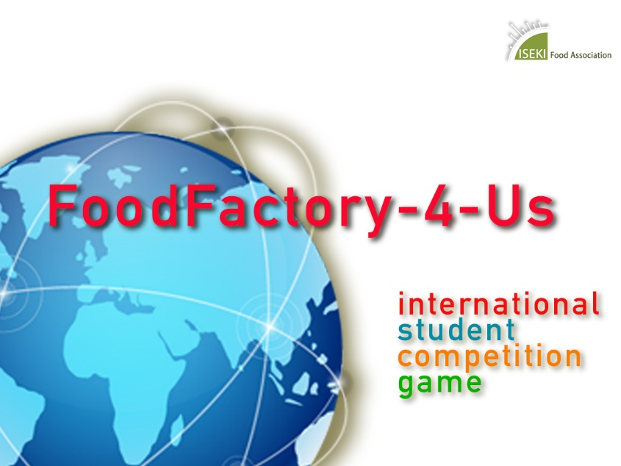

PROJECT REPORT Food Factory-4-Us 2019/2020

Team name:
Project title:

Teams will submit 15 February 2020 by email to ssc@iseki-food.net:
- The project report of maximum 4 pages
- The presentation of maximum 20 slides (in ppt format) to be presented at the FoodFactory-4-Us Final Virtual Conference in Sustainable Cereals 6 March 2020 from 12.30 - 16.00 CET

Evaluation criteria can be found at https://food-sta.eu/ssc2019-b/project-topic-and-evaluation

The Project Report of maximum 4 pages (single spaced, Times New Roman, 11 Font, standard margins, including references) has to include the following:
- Abstract (150 words maximum)
- Keywords (3-5 maximum)
- Main objectives (200 words maximum)
- Strategy of the project: How the challenge/problem was identified, how it has been studied in the past and the solution(s) identified and developed here (200 words maximum)
- Development of the project: Full description of the challenge/problem and all aspects considered in the solution (2 pages maximum)
- Innovation, potential applicability and benefits in respect to the state of the art (200 words maximum)

Use this document for your report.
Delete the instruction boxes and the banner and start your report with your abstract underneath the Project Title.

